The contribution of trees and silvopasture to a small mixed farm in Northern Ireland
I was raised on Kilowna Farm on the east coast of Co Down (2 miles from the most easterly point on the island of Ireland). The farm is a small, family run mixed farm-sheep, grass and cereal.
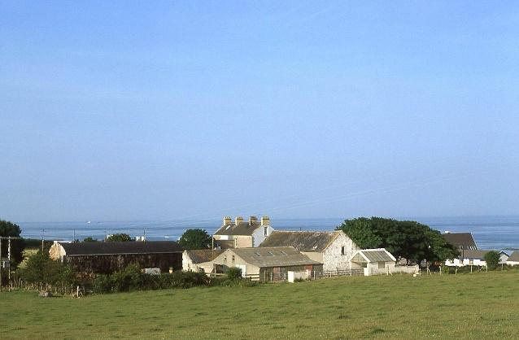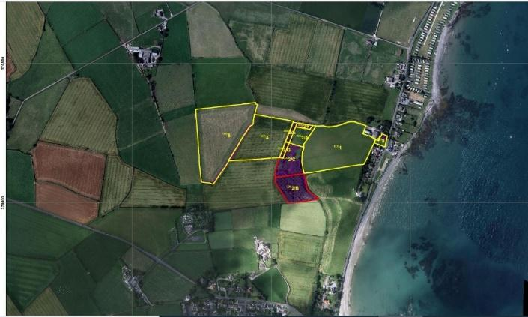
Kilowna Farm
I had an input into the managing the farm most of my professional life (I was an agricultural scientist and University lecturer) and inherited the farm house, yard and 12.5 ha (30ac) in 2018. Down is the least wooded county in N Ireland (2.4%) and the farm is on the Ards peninsula, an intensive tillage and grass area. I have always been keen on the role trees can play on the farm and managed to combine my research and interest in silvopasture over the years in a practical way.
Typical landscape around the farm
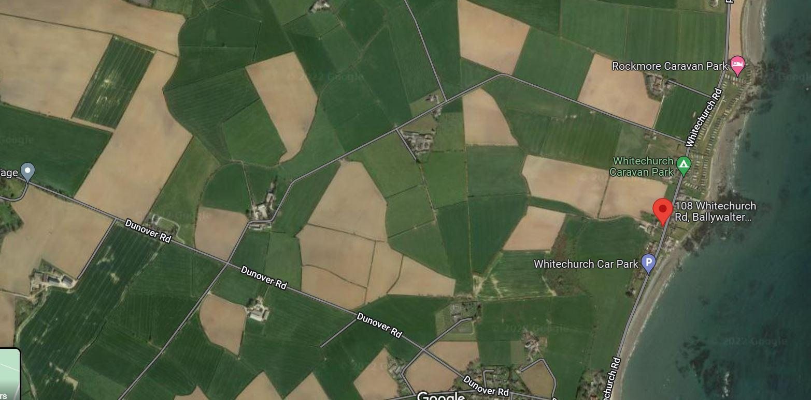
There are 7 fields on the farm
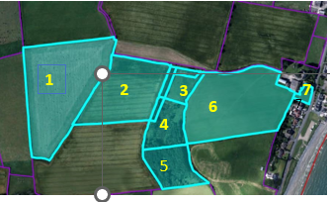

Field | Use | Area (ha)
1 | Grass over 5yrs | 3.86
2 | Arable-spring barley | 2.35
3 | Permanent grass | 0.38
4 | Silvopasture | 0.9 (0.6 eligible)
5 | Woodland | 1.27
6 | Grass under 5 yrs | 3.54
7 | Permanent grass (+0.03 ha silvopasture) | 0.1
This gives me a land use breakdown as follows:-
Use | Area (ha) | %
Permanent grass (>5 yrs) | 4.38 | 35
Temporary grass ley | 3.54 | 28
Arable | 2.35 | 19
Silvopasture | 0.93 | 8
Woodland | 1.27 | 10
TOTALS | 12.52 | 100

Biodiversity /Habitats
I haven’t carried out any major ecological studies, but the RSPB use my farm as a monitoring farm (I retain overwinter stubble on the cereal field) and I am happy to say Yellowhammers were recorded on the farm last year. From the table above, 18% of the farm is in trees or silvopasture, over twice the national average tree cover for NI (7 %) and over 7 times the average for Co Down. I have just completed 530 m of a planted riparian buffer strip (2m wide).
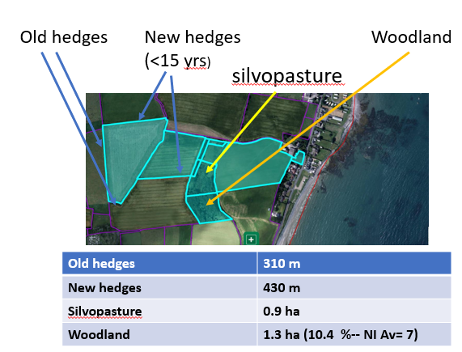
The woodland, stream (an offshoot of the Ganaway Burn) and hedges are my best biodiversity source on the farm. There are 310m of old hedges on the farm, 430m of new hedges I planted about 18years ago (under a Department agri-environment scheme). This gives me a hedgerow density of 9.7 km/sq km -above the national average of 8.8 km/sq km. Recently an otter was seen in the river for the first time https://twitter.com/AgroforestForum/status/1642860375451267074?s=20

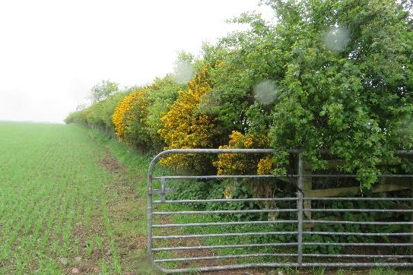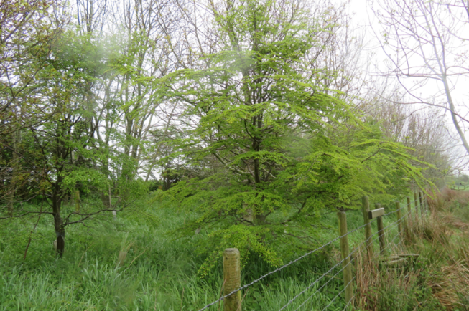
Hedge planted in 2004. I have tried some southern beeches in the shelterbelts
Silvopasture on the farm
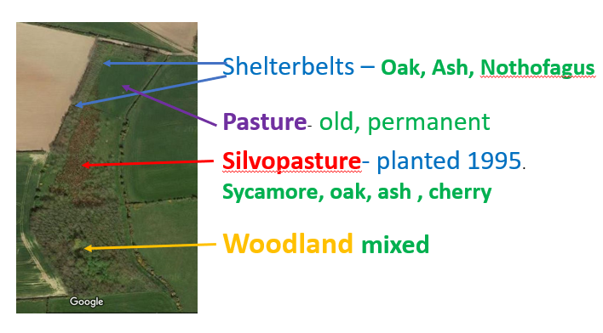
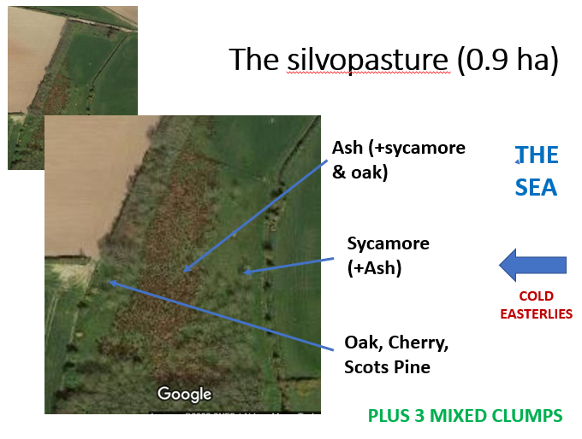

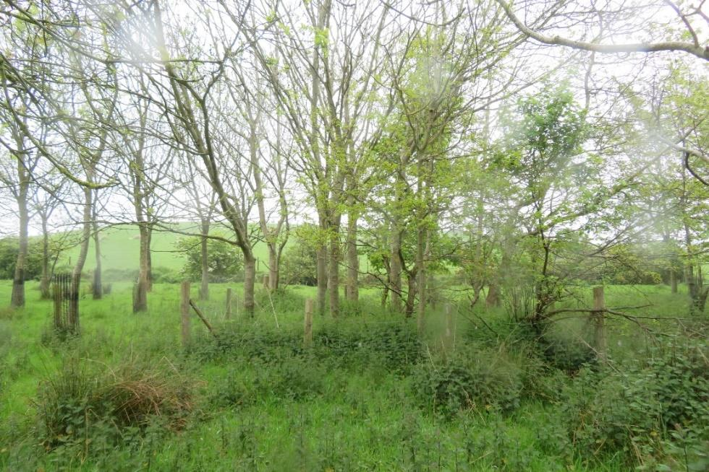
Some of the silvopasture is mixed clump planting. I will take away the fences.
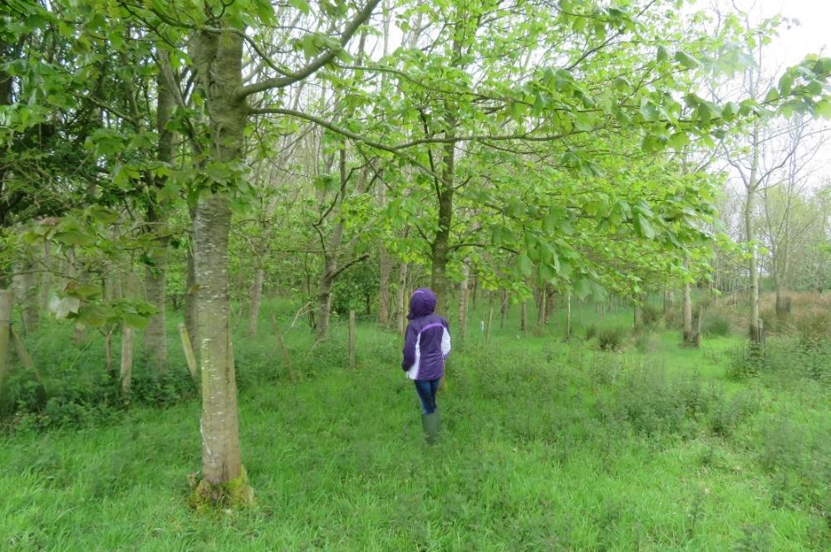
Given the coastal location, Sycamores are the most successful species. The ash are now dying off.

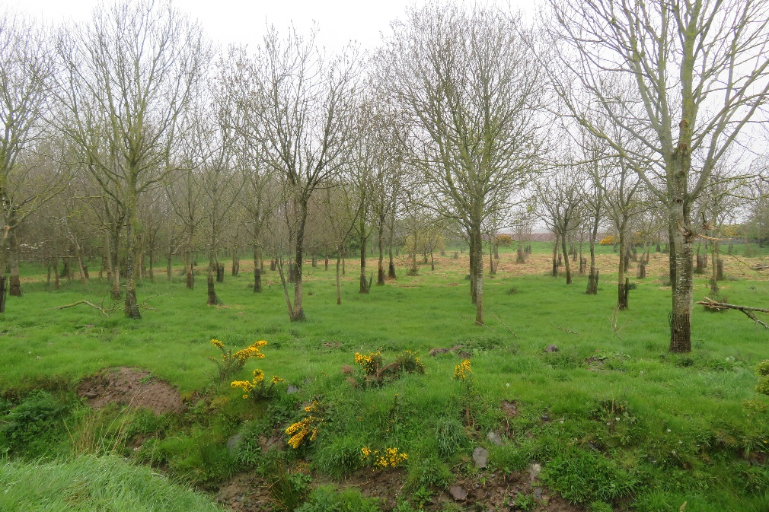
Carbon audit (2022)
I have made use of the 1:50,000 soil map of Northern Ireland (Sheet 11) to use soil type to calculate soil carbon content.
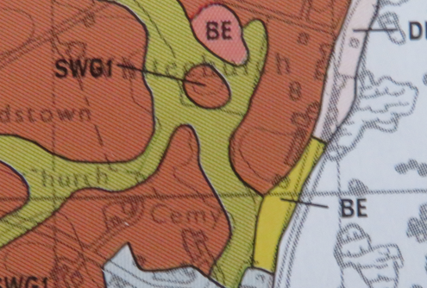
Land use | area | tC/ha in vegetation | Total C (t) in vegetation | tC/ha in soil | Total C (t) in soil | Total Carbon  t | Estimated C sequestration potential (tC/yr)
Pasture | 7.9 | 1.8 | 14.22 | 170.2 | 1345 | 1359 | 6.32
Arable | 2.4 | 1.0 | 2.4 | 144.1 | 346 | 348 | -1.2
Woodland/Shelter belt | 1.3 | 28.5 | 37.1 | 226.2 | 294 | 331 | 4.94
Agroforestry | 0.9 | 15.0 | 13.5 | 166 | 149 | 163 | 2.9
Hedges¹ | 0.16 | 29.5 | 4.7 | 199.5 | 31.9 | 37 | 0.48
 |  |  | 71.92 |  | 2167 | 2238 | 13.44
¹ Assuming 740m hedges c 2m wide. With 15tC/ha (old hedges) 40tC/ha (new hedges) above and below ground Sequestration potential 3t/C/ha/yr
Of my total carbon audit (2238 t) 24 % is in the 18% of the farm under trees (inc hedges). Although 82% of the farm is under grass, only 47% of the potential sequestration comes from the pasture. Increasing the area of any of the woody components of the farm (ie planting some of the arable or pasture land) will have most impact on sequestration.

Financial performance 2020-21 (£)
Enterprise
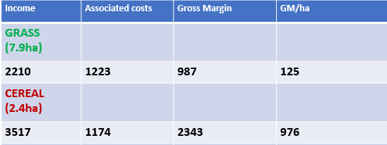

Farm
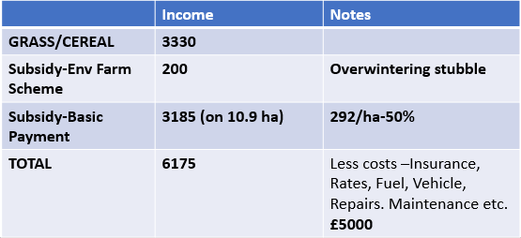

Summary points- the position in 2022
- The farm has much better habitat quality than average for the area and better than the national average
- The trees make a significant contribution to the carbon balance of the farm- woodland, hedges and silvopasture (grazed ) account for 18% of the farm area and 22 % and 78% of the soil and above ground biomass respectively.
- Planting more silvopasture and hedges offers the best chance to sequester more carbon.
- The farm is not financially viable without subsidy (half the farm income last year), so keeping subsidy is vital
- As silvopasture is treated as agricultural land in NI, For the future, having more silvopasture would improve soil health and increase the farm carbon stock without loss of subsidy

Going forward – 2023
- Participated in Soil Nutrient Health Scheme.
Riparian Buffer Planting
- Successful application was made to DAERA’s Environmental Farming scheme (EFS- Wider)-for Riparian Buffer and Retention of winter stubble (RWS) options.
- Riparian Buffer - 530m of 2m wide riparian buffer fenced off and (still to be) planted with native trees at approx. 2.5m intervals (as per DAERA specification-see below) in groups . Trees supplied by Trees on the Land.
- RWS -Retained 3.54ha of winter stubble. (Field 2)

Riparian Buffers (yellow)
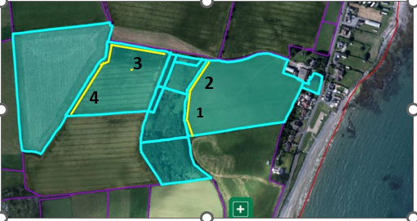

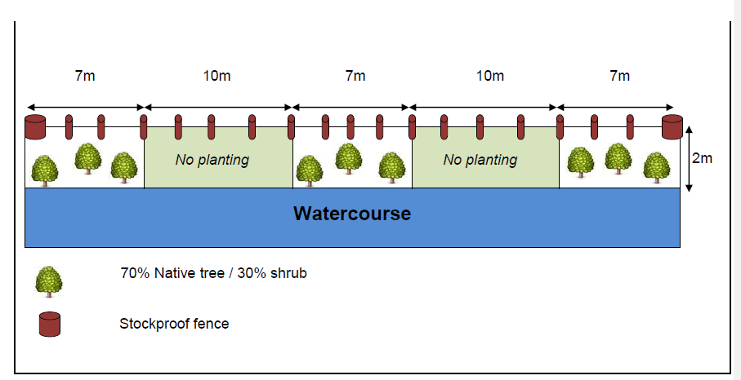

DAERA planting specification for Riparian Buffer planted with native trees

Features of note –
- Buffer zone 1 is alongside the agroforestry field
- Buffer zone 2 bounds a field with 2 hardwood shelterbelts which will be grazed
- An otter has been seen in stream 4.
The fencing has been erected and the buffer zones established. Trees and bushes planted in April 2023.- Scots Pine, Crab apple, Spindle, Hazel, Hawthorn. Willow, Birch, Alder, Rowan, Gorse.

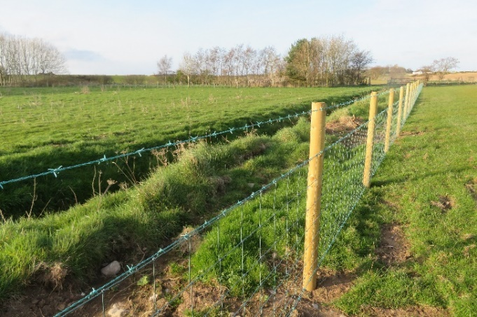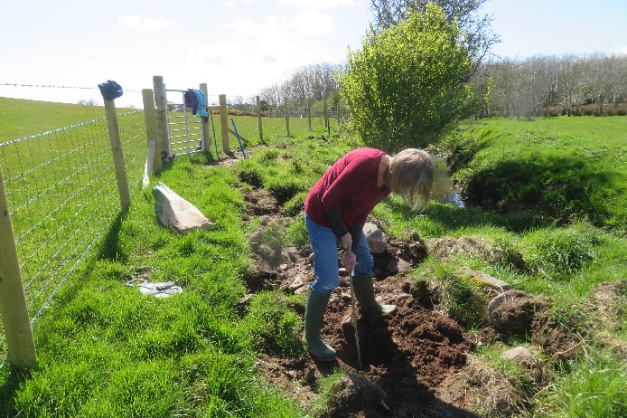

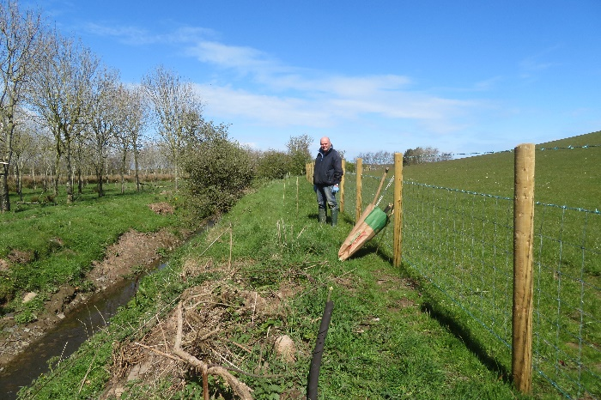
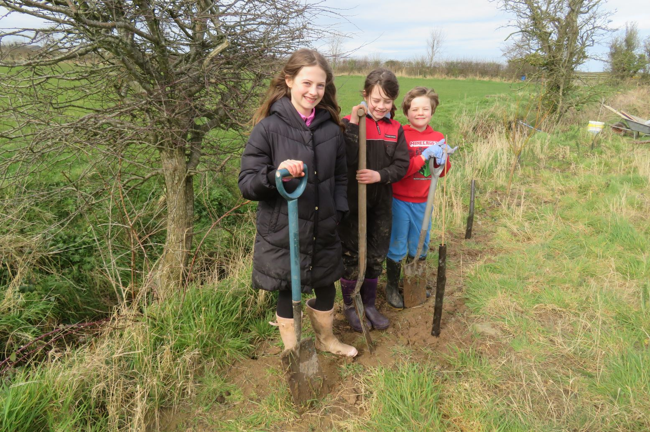
Grandchildren Rosalie, Niamh and James Wells planting more of the riparian buffer (trees from Trees on the Land) in March this year.
Silvopasture. This had been neglected for some years. The rushes have been cut, weak spindly and dying ash trees removed and additional planting will be carried out next season. The whole area is looking much more diverse and like a viable, productive silvopastoral contribution to the farm.
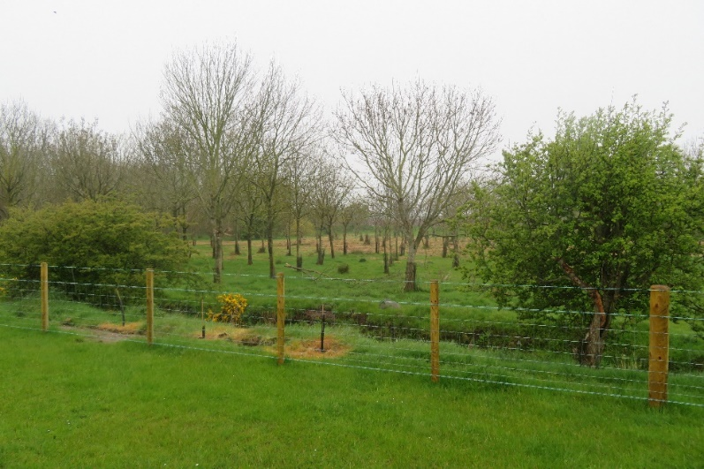
The silvopasture with recent riparian buffer planting in the foreground (March 2023)

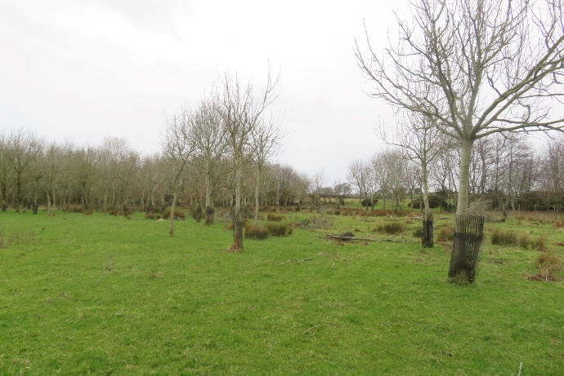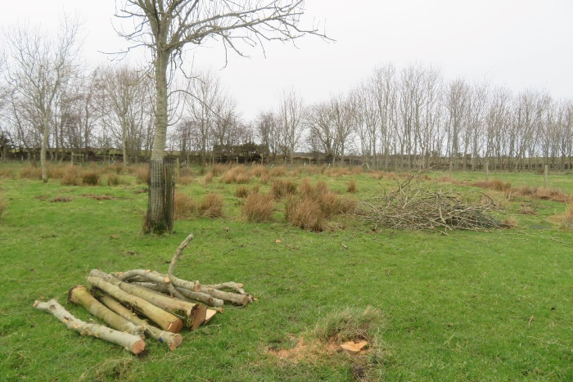
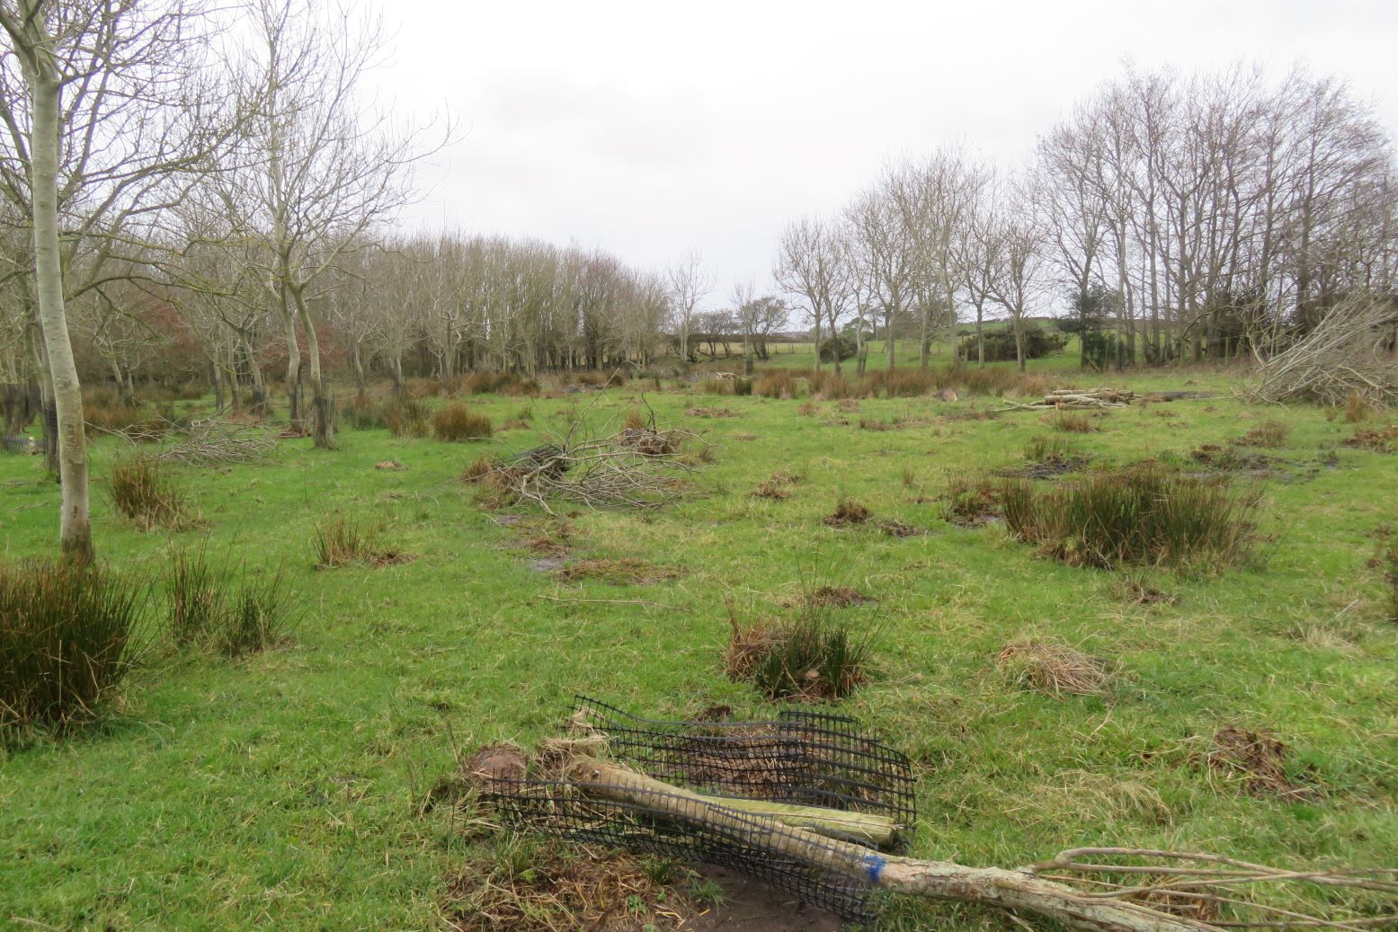
After recent thinning removal of diseased ash.
Thanks. For farm management, support and an excellent video of the otter, John Kennedy, Templefyn Farm Ballywalter. Imogen Rabone, Trees on the Land, (www.treesontheland.com) for providing trees: Bronagh O’Kane, GrowIN (www.growin.land), for caring for the trees and promotion; Maureen Kilgore for Irish Agroforestry Forum support (www.irishagroforestry.ie): Geraldine McAdam, Niamh, James and Rosalie Wells for tree planting, Stephen Gibson and Eileen Keenan for thinning.
Jim McAdam
108, Whitechurch Road, Ballywalter, Co Down BT22 2JY. Jim.mcadam100@outlook.com
Tel : -07796614870

